Effective Automation Using Existing Equipment
Industry: Agrifood Processing
Focus: Throughput Optimization with Legacy Systems

● At a Glance

- Aging agrifood plant with manual screw feeder control.
- Operators underfed system to avoid clogging due to material variability.
- No usable sensors; vendor options too expensive or unfit.
- Introduced closed-loop control logic using only existing hardware.
- Achieved immediate 6% increase in daily throughput.

🏭 The Situation
The client operated an aging agrifood processing plant where throughput hinged on a manually controlled screw feeder. Operators adjusted the speed through a wall-mounted variator. Given the biological nature of the feed material—its properties changed with humidity, season, storage, and ripeness—there was a constant risk of clogging. This led to cautious underfeeding.
Instrumentation was primitive. Mechanical detectors triggered only when buildup was already severe. Vision systems were proposed but rejected due to dust, housekeeping complexity, and cost. Physical block removal was arduous and hazardous, reinforcing operator reluctance to raise feeder speeds.
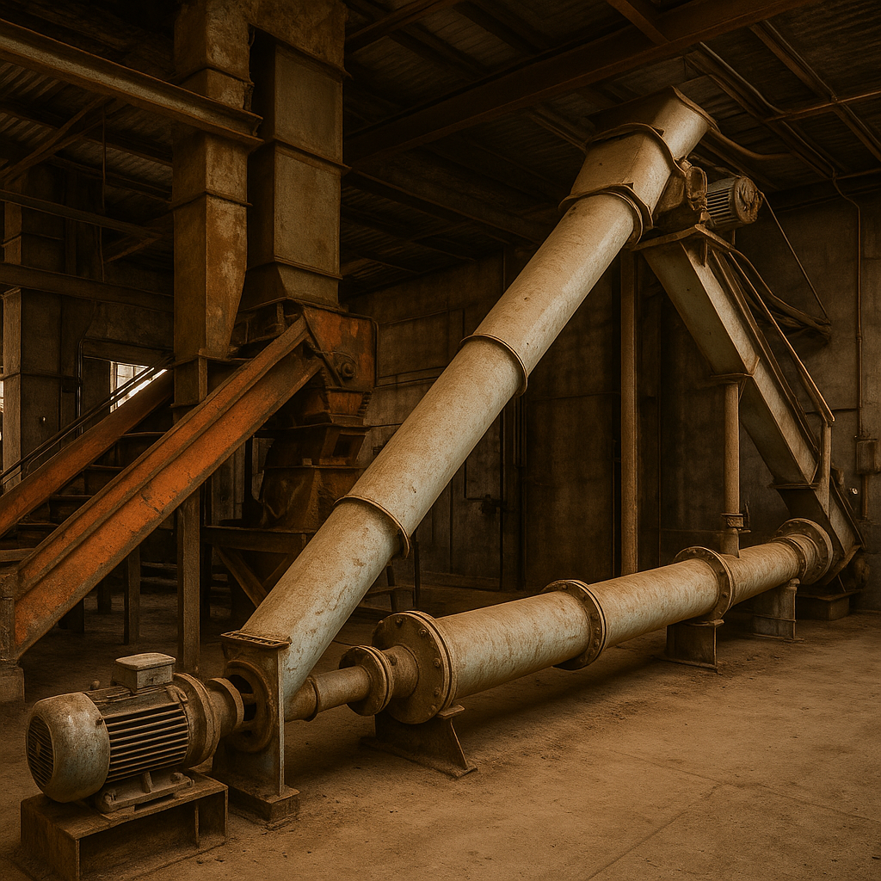

❌ The Challenge
- No reliable sensor feedback for early detection.
- High operator caution rooted in real ergonomic risk.
- Tight budget and low confidence in automation.
- Needed to work with existing motors, detectors, and SCADA only
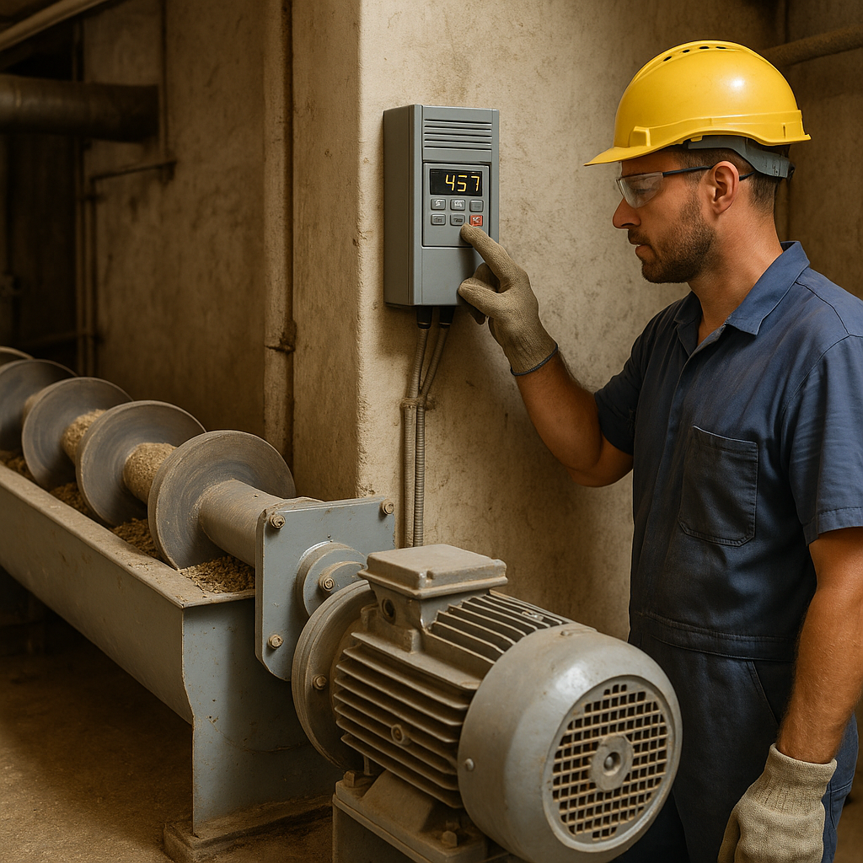

🔬 The Underlying Theory
The goal was to automate where manual control caused avoidable inefficiencies. Overfeeding led to motor overloads and visible spills—conditions already detected by limit switches, but far too late to act on. Subtle fluctuations in motor load or torque, however, offered predictive signals.
The problem wasn't lack of data—it was poor resolution and reactive logic. By capturing high-frequency data and correlating it with failure events, we could define control thresholds that predicted trouble before it occurred.
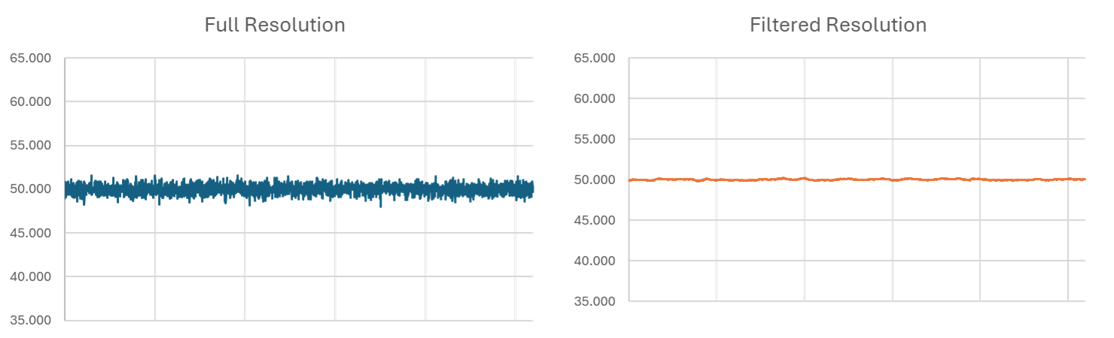

🔧 Our Approach
We first reconfigured the SCADA system to collect high-resolution data from all relevant motors and limit switches. This eliminated the smoothing effects of slower sampling that had obscured momentary peaks.
Correlating these peaks with actual clogging events revealed three distinct load zones:
- Green Zone: stable operation.
- Yellow Zone: risk emerging.
- Red Zone: failure imminent

We then created a soft logic routine:
- Operator sets a target speed remotely.
- System ramps up slowly to allow absorption.
- If load enters Yellow, feeder slows gradually.
- If load reaches Red, alarm is triggered and deceleration accelerates.
- When Green is regained, speed slowly ramps up again
This closed-loop logic mimicked operator caution—but with faster, more consistent response.
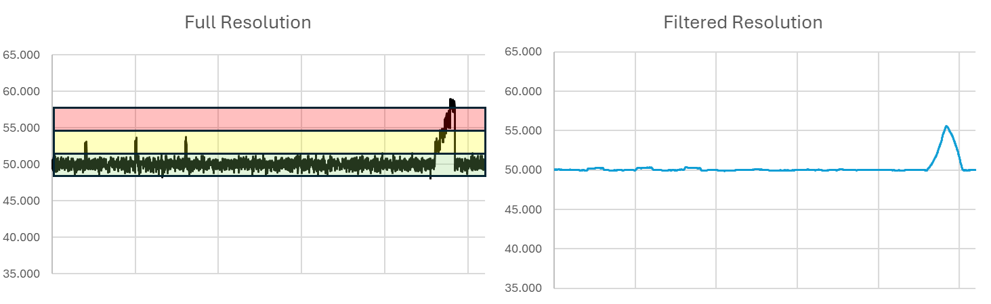

✅ The Results

✅ Operational Gains:
- +6% in daily throughput, instantly achieved.
- Reduced blockages and smoother line performance.
- More consistent flow improved product quality.
- Reduced waste, auxiliary inputs, and energy loss.
- Operation now sustained near peak without manual micromanagement

✅Organizational Impact:
- Operators shifted from skepticism to full support.
- System adoption grew as reliability became evident.
- The most skeptical operator eventually claimed credit for the idea.
- Sparked a wave of operator-initiated automation proposals.

💡 Takeaway
- Start with the signals you already have
You don’t need high-end tech to predict failures. Subtle data, read at the right resolution, can be enough to drive stable control.

- Design automation to complement operator caution
Operators weren’t the problem—they were a buffer against poor design. Codifying their logic earned trust and improved adoption.

- No new gear. Just better thinking.
Throughput increased, variability dropped, and costs fell—with zero capital spend. The gains were engineered, not purchased.

Written by Yair Riffkin. With over two decades of experience in operational performance, manufacturing technology, and data-driven process transformation across global industries.
🔗 Connect with me on Linkedin
🌐 Visit Yeda Solutions

